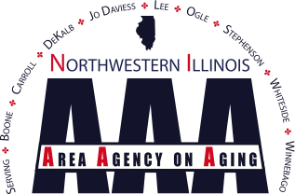

Needs Assessment for 2025 Area Plan

Dear Interested Person or Organization:

NIAAA is in the process of developing our area plan which will begin in October 2024. As part of the planning process, we need your feedback on funding priorities. Please take a moment and answer the following questions. Feel free to use additional pages and/or just send us an email at gnyhammer@nwilaaa.org with your comments by February 1, 2024.

Name of Organization / Person (optional): ______________________________________

1. Community Services (Title III-B)
NIAAA currently funds the following community services. Please indicate if the funding is adequate, inadequate and add any relevant comment.

Adequate Inadequate Comment
- Information and Assistance □ □ _______________
- Transportation □ □ _______________
- Legal □ □ _______________
- Ombudsman □ □ _______________
- Miscellaneous financial help □ □ _______________

Are there other community services that NIAAA should fund? Please describe.
____________________________________________________________________________________________________________________________________________________

2. Meals (Title III-C1 and C2)
NIAAA funds both congregate and home delivered meals. Please indicate if the funding is adequate, inadequate and add any relevant comment.

Adequate Inadequate Comment
- Congregate meal □ □ _______________
- Home delivered meals □ □ _______________

Any suggestions for improving the meal programs?__________________________________
__________________________________________________________________________________________________________________________________________________________________________________________________________________________________________________________________________________________________________________________________________________________________________________

3. Disease Prevention & Health Promotion (Title III-D)
NIAAA funds services for disease prevention and health promotion services at senior centers, congregate meal sites, through home delivered meal programs, etc.

Do you have any suggestions or comments regarding these services?__________________
__________________________________________________________________________
__________________________________________________________________________

4. Caregiver Support Program (Title III-E)
NIAAA funds the Caregiver Support Program. Do you have any suggestions or comments regarding these services?_____________________________________________________
__________________________________________________________________________

5. Other needed services
Do you have suggestions for other needed services? Please describe._________________
__________________________________________________________________________.

6. Additional information
Please provide any additional information of which you think NIAAA should be aware.
____________________________________________________________________________________________________________________________________________________

